

NATIONAL INSTITUTE OF TECHNOLOGY KARNATAKA

SURATHKAL, MANGALORE - 575 025

Course Code – CS254

Course Name – Database Systems Lab

Lab - 05

Date – March 2, 2022

Submitted To

Dr. Annappa B

Department of Computer Science and Engineering

National Institute of Technology Karnataka, Surathkal

Submitted By

Md Rakib Hasan

Roll – 201CS132

Department of Computer Science and Engineering

**1. Build a basic database (of your choice) and explore the usage of following string function:**

**CHAR_LENGTH()**

**CONCAT()**

**INSERT()**

**LCASE()**

**LENGTH()**

**LIKE**

**TRIM()**

**STRCMP()**

**SUBSTR()**

SELECT

    CONCAT(first_name, " ", last_name) as concat,

    CHAR_LENGTH(first_name) as char_length,

    LENGTH(first_name) as length,

    LCASE(first_name) as lcase,

    INSERT(first_name, 1, 5, "HELLO") as insertf,

    TRIM(first_name) as trim,

    STRCMP(first_name, "Ines") as strcmp,

    SUBSTR(first_name, 1, 2) as substr

FROM customers;

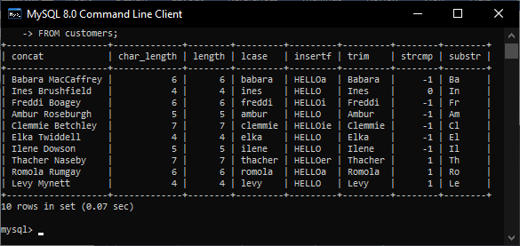

**2. Create database with**

**PATIENT (p_id, r_id, d_id, p_name, city, contact, p_date),**

**DOCTORS (d_id, name, salary, specification),**

**ROOM (r_id, room_type)**

**TEST & DIAGNOSIS (p_id, diagno, diag_details),**

**(Insert new five values for each table. Assume the necessary values related to below mentioned questions.)**

**(Add 10 entries for each table)**

**Draw the ER diagram for the above database.**

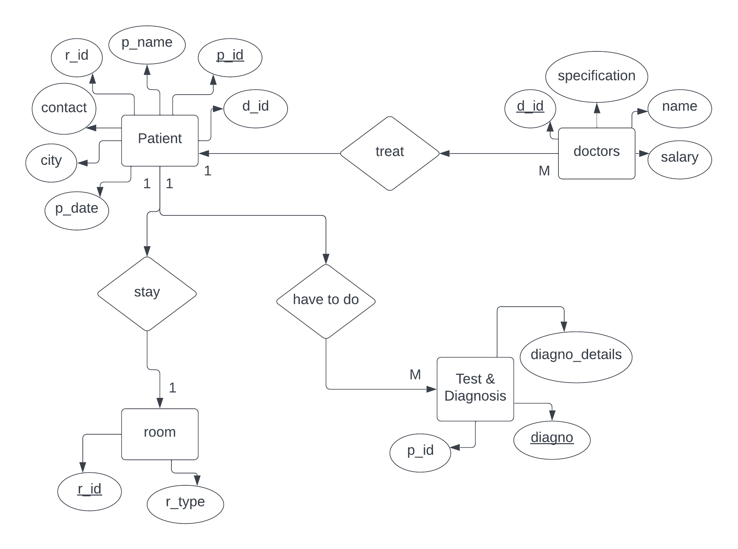

CREATE DATABASE hospital;

USE hospital;

CREATE TABLE doctors (

    d_id INT NOT NULL,

    name VARCHAR(50),

    salary INT,

    specification VARCHAR(50),

    PRIMARY KEY (d_id));

CREATE TABLE room (

    r_id INT NOT NULL,

    room_type VARCHAR(20),

    PRIMARY KEY (r_id))

CREATE TABLE patient (

    p_id INT NOT NULL,

    r_id INT NOT NULL,

    d_id INT NOT NULL,

    p_name VARCHAR(50),

    city VARCHAR(50),

    contact VARCHAR(50),

    p_date DATE,

    PRIMARY KEY (p_id),

    FOREIGN KEY (r_id) REFERENCES room(r_id),

    FOREIGN KEY (d_id) REFERENCES doctors(d_id));

CREATE TABLE test_diag (

    p_id INT NOT NULL,

    diagno INT NOT NULL,

    diag_details VARCHAR(50),

    PRIMARY KEY (diagno),

    FOREIGN KEY (p_id) REFERENCES patient(p_id));

INSERT INTO doctors

    VALUES (201, "Doc A", 100000, "Heart"),

    (202, "Doc B", 100000, "Ear"),

    (203, "Doc C", 80000, "Eye"),

    (204, "Doc D", 12100, "Skin"),

    (205, "Doc E", 12000, "AA"),

    (206, "Doc F", 10100, "BB"),

    (207, "Doc G", 10010, "CC"),

    (208, "Doc H", 10080, "DD"),

    (209, "Doc I", 10090, "EF"),

    (210, "Doc J", 100100, "GH");

INSERT INTO room

    VALUES (1, "Room A"),

    (2, "Room B"),

    (3, "Room C"),

    (4, "Room D"),

    (5, "Room E"),

    (6, "Room F"),

    (7, "Room G"),

    (8, "Room H"),

    (9, "Room I"),

    (10, "Room J");

INSERT INTO patient

    VALUES (101, 1, 201, "Patient A", "Dhaka", "01521", "2010-01-01"),

    (102, 2, 202, "Patient B", "Tangail", "01521001", "2012-01-01"),

    (103, 3, 201, "Patient C", "Rajshahi", "0152147", "2013-01-01"),

    (104, 4, 203, "Patient D", "Mymensingh", "01520111", "2014-01-01"),

    (105, 5, 203, "Patient E", "Chandpur", "0152146", "2017-01-01"),

    (106, 6, 201, "Patient F", "Cumilla", "01146461", "2010-02-01"),

    (107, 7, 204, "Patient G", "Kolkata", "046421", "2010-05-01"),

    (108, 8, 201, "Patient H", "Dilhi", "01589", "2010-09-01"),

    (109, 9, 205, "Patient I", "Karnataka", "01571", "2010-04-01"),

    (110, 10, 206, "PatientJA", "Mangalore", "0821", "2010-07-01");

INSERT INTO test_diag

    VALUES (101, 501, "ECG"), (102, 502, "XA"), (102, 503, "XB"),

    (104, 504, "XC"),

    (105, 505, "XD"),

    (105, 506, "XE"),

    (107, 507, "XF"),

    (108, 508, "XI"),

    (104, 509, "XJ"),

    (101, 510, "XK");

**List the patient details with multiple diagnosis records.**

SELECT p_id, COUNT(*) AS total_diagnosis

FROM test_diag

GROUP by p_id

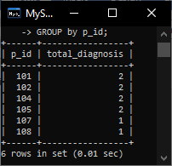

**Add a new attribute p_date (i.e hospital joining date) to the PATIENT table.**

**Fetch the doctors who do not have any patients.**

SELECT *

FROM doctors

WHERE d_id NOT IN (

    SELECT d_id

    FROM patient

    GROUP BY d_id)

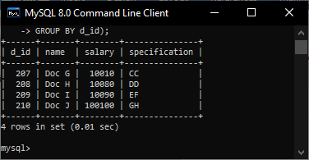

**Display doctors’ salary in ascending order.**

SELECT *

FROM doctors

ORDER BY salary DESC

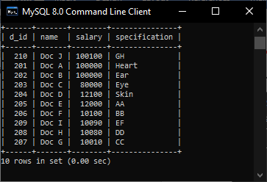

**Display each patient details through diagd_details.**

SELECT *

FROM patient

WHERE p_id IN (

    SELECT DISTINCT p_id

    FROM test_diag)

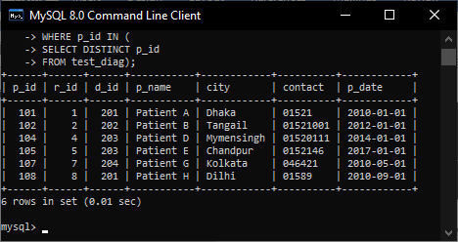

**Display the number of patients for each doctor. Only include doctors with more than 3 patients.**

SELECT *, count(*) as total_patient

FROM patient

GROUP BY d_id

HAVING total_patient > 3

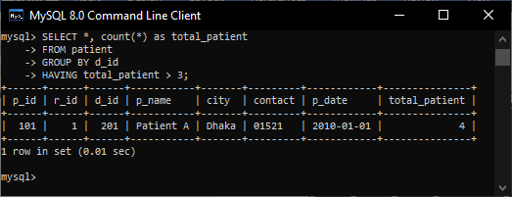

**Display the doctors who are treating patients from r_id 102 to 105.**

SELECT *

FROM patient

WHERE r_id BETWEEN 2 AND 5

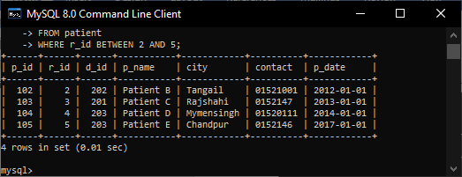

**Display the patients details according to their joining dates.**

SELECT *

FROM patient

ORDER BY p_date DESC

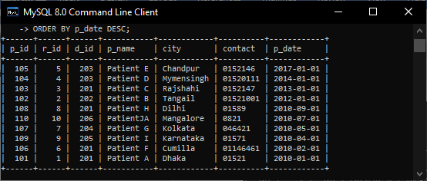

**Count the patients who took deluxe rooms.**

SELECT count(*) AS deluxe_room_taken

FROM patient

WHERE r_id IN (

    SELECT r_id

    FROM room

    WHERE room_type IN ("Room A", "Room B"))

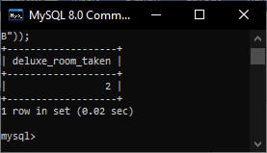

**Display name of the doctor with salary less than 40000**

SELECT *

FROM doctors

WHERE salary < 40000

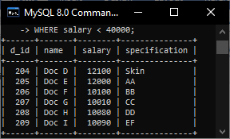

**Display the patients joined before 10.10.2017.**

SELECT *

FROM patient

WHERE p_date < "2017-10-10"

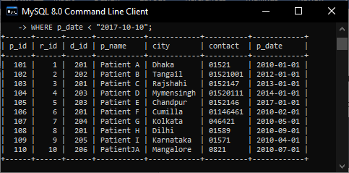

**Create database for below Schema**

**(Add 10 entries for each table)**

**BOOK (Book_id, Title, Publiser_name, pub_date)**

**BOOK_AUTHORS (book_id, author_name)**

**PUBLISHER (fname, lname, address, phone)**

**BOOK_COPIES (book_id, programme_id, no_of_copies)**

**BOOK_LENDING (book_id, programme_id, card_no, date_out, due_date)**

CREATE DATABASE library;

USE library;

CREATE TABLE book (

    book_id INT NOT NULL,

    title VARCHAR(255),

    publisher_name VARCHAR(255),

    pub_date DATE,

    PRIMARY KEY (book_id));

CREATE TABLE book_authors (

    book_id INT NOT NULL,

    author_name VARCHAR(255),

    FOREIGN KEY (book_id) REFERENCES book(book_id)

ON DELETE CASCADE

ON UPDATE CASCADE

);

CREATE TABLE publisher (

    fname VARCHAR(50),

    lname VARCHAR(50),

    address VARCHAR(50),

    phone VARCHAR(20));

CREATE TABLE BOOK_COPIES (

    book_id INT NOT NULL,

    programme_id INT NOT NULL,

    no_of_copies INT,

    primary key (programme_id),

    FOREIGN KEY (book_id) REFERENCES book(book_id)

ON DELETE CASCADE

ON UPDATE CASCADE);

CREATE TABLE BOOK_LENDING (

    book_id INT NOT NULL,

    programme_id INT NOT NULL,

    card_no INT NOT NULL,

    date_ouT DATE,

    due_date DATE,

    FOREIGN KEY (programme_id) REFERENCES book_copies(programme_id)

ON DELETE CASCADE ON UPDATE CASCADE,

    FOREIGN KEY (book_id) REFERENCES book(book_id)

ON DELETE CASCADE ON UPDATE CASCADE);

INSERT INTO book

    VALUES (101, "Book A", "Publishar A", "2017-01-01"),

    (102, "Book B", "Publishar B", "2013-01-01"),

    (103, "Book C", "Publishar C", "2014-01-01"),

    (104, "Book D", "Publishar D", "2015-01-01"),

    (105, "Book E", "Publishar E", "2012-01-01"),

    (106, "Book F", "Publishar F", "2011-01-01"),

    (107, "Book G", "Publishar G", "2010-01-01"),

    (108, "Book H", "Publishar H", "2003-01-01"),

    (109, "Book I", "Publishar I", "2022-01-01"),

    (110, "Book J", "Publishar J", "2021-01-01");

INSERT INTO book_authors

    VALUES (101, "Author A"),

    (102, "Author B"),

    (103, "Author C"),

    (104, "Author D"),

    (105, "Author E"),

    (106, "Author F"),

    (107, "Author G"),

    (108, "Author H"),

    (109, "Author I"),

    (110, "Author J");

INSERT INTO publisher

        VALUES ("Pub First A", "Pub Last A", "Address A", "012"),

        ("Pub First B", "Pub Last B", "Address B", "013"),

        ("Pub First C", "Pub Last C", "Address C", "014"),

        ("Pub First D", "Pub Last D", "Address D", "015"),

        ("Pub First E", "Pub Last E", "Address E", "016"),

        ("Pub First F", "Pub Last F", "Address F", "017"),

        ("Pub First G", "Pub Last G", "Address G", "018"),

        ("Pub First H", "Pub Last H", "Address H", "019"),

        ("Pub First I", "Pub Last I", "Address I", "010"),

        ("Pub First J", "Pub Last J", "Address J", "011");

INSERT INTO BOOK_COPIES

    VALUES (101, 201, 5), (102, 202, 4), (103, 203, 7), (104, 204, 8),

    (105, 205, 23), (106, 206, 1),

    (107, 207, 0),

    (108, 208, 10),

    (109, 209, 53),

    (110, 210, 50);

INSERT INTO book_lending

    VALUES (101, 201, 301, "2017-01-01", "2017-02-01"),

    (102, 202, 302, "2018-01-01", "2018-02-01"),

    (103, 203, 303, "2019-01-01", "2019-02-01"),

    (104, 204, 304, "2020-01-01", "2020-02-01"),

    (105, 205, 305, "2021-01-01", "2021-02-01"),

    (106, 206, 306, "2022-01-01", "2022-02-01"),

    (107, 207, 307, "2016-01-01", "2016-02-01"),

    (108, 208, 308, "2015-01-01", "2015-02-01"),

    (109, 209, 308, "2014-01-01", "2014-02-01"),

    (110, 210, 310, "2013-01-01", "2013-02-01");

**Retrieve details of all books in the library – id, title, name of publisher.**

SELECT book_id, title, publisher_name

FROM book;

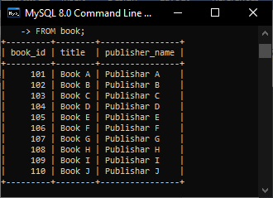

**Retrieve the books which have been borrowed from Jan 2017 to March 2017**

SELECT *

FROM book_lending

WHERE date_ouT BETWEEN "2017-01-01" AND "2017-03-01";

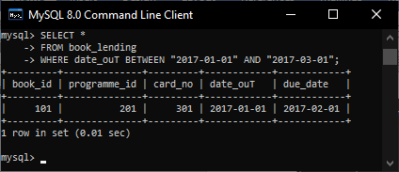

**Delete a book in the BOOK table. Update the contents of other tables to reflect this data manipulation operation.**

DELETE FROM book WHERE book_id = 101

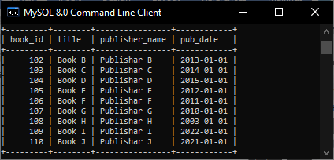

**Retrieve the details of the books(id, title, publisher name, year) published on the date 20-03-1998**

SELECT *

FROM book

WHERE pub_date = "1998-03-20"

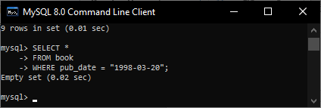

**Retrieve the books published by a particular author.**

SELECT *

FROM book

WHERE book_id = (

    SELECT book_id

    FROM book_authors

    WHERE author_name = "Author B")

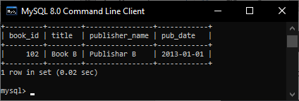

**Create a column name in the Publishers table. Combine FName and LName and print it in column name.**

ALTER TABLE publisher

ADD fullName VARCHAR(50);

UPDATE publisher

SET fullName = concat(fname," ",lname);

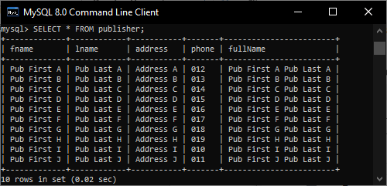

**Write a query to display the first day of the month (in datetime format) two months before the current month from the date of publication of the book “DBMS”**

SELECT pub_date,

    DATE_SUB(pub_date, INTERVAL 2 MONTH),

    DATE_SUB(DATE_SUB(pub_date, INTERVAL 2 MONTH),INTERVAL DAYOFMONTH(DATE_SUB(pub_date, INTERVAL 2 MONTH))- 1 DAY),

    DAYNAME(DATE_SUB(DATE_SUB(pub_date, INTERVAL 2 MONTH),INTERVAL DAYOFMONTH(DATE_SUB(pub_date, INTERVAL 2 MONTH))- 1 DAY))

FROM book

WHERE title = "Book B"

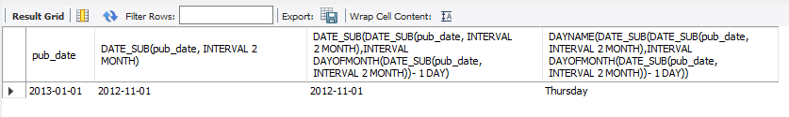

**Write a query to get years in which more than 3 books were published.**

SELECT YEAR(pub_date) as year, count(*) as total_book_published

FROM library.book

group by YEAR(pub_date)

HAVING total_book_published > 2;

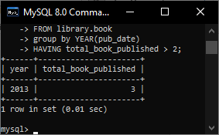

**Print the number of copies of a particular book.**

SELECT no_of_copies FROM book_copies WHERE book_id = 102;

